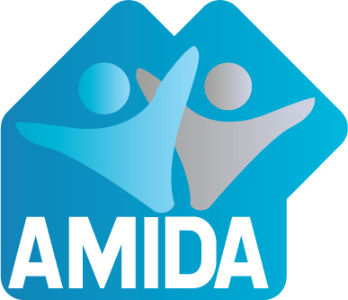
Action for More Independence & Dignity in Accommodation

1st Floor, Ross House, 247 Flinders Lane, Melbourne Vic 3000
Phone: 9650 2722 Fax: 9654 8575
Email: amida@amida.org.au Website: www.amida.org.au
Inc No: A001608SV ABN: 32 993 870 380

Advocacy, Self Advocacy, Rights, Accessibility, & Community Living for People with a Disability

29th February 2016

Feedback to the Joint Standing Committee on the NDIS

Action for More Independence and Dignity in Accommodation (AMIDA) supports people with disability as valued members of our community. AMIDA recognises that people with disability contribute to and develop our community.
AMIDA acknowledges that people with disability have a right to a choice of who they live with and where they live. Further, people with disability have a right to good quality housing which is accessible, affordable and non-institutional. People with disability have a right to live in the community with access to support to participate and have a good quality of life.
AMIDA is an independent advocacy organisation which advocates for good housing for people with disability. We provide advocacy to individuals, with priority given to people with an intellectual disability, and advocate for change in systems which prevent people from achieving good housing.
AMIDA strongly supports the United Nations Convention on the Rights of Persons with a Disability and works to assert these rights and community inclusion for people with a disability
The following is our submission to the Joint Standing Committee on the National Disability Insurance Scheme on Accommodation for people with disabilities and the NDIS.
AMIDA commends the Joint Standing Committee for holding the Roundtable on Housing, publishing the transcript and seeking more solutions, innovations and possible funding models. The contributions so far have been illuminating. Capturing and sharing the work that has been done by people with a disability, families, community, housing and disability service providers is important and the report the standing Committee produces will be a useful road map for all levels of government and the community. The submissions and contributions will be the beginning of a useful resource base going forward especially in an environment where information, co-operation and collaboration may well be the most important solution to the accommodation needs of people with a disability.
AMIDA was one of the first to develop community housing as an alternative to large institutions however we have not been involved in the establishment of housing for more than 20 years. Our expertise since that time is in advocacy; not in financing and developing housing. We were encouraged to see the detailed work of the Summer Foundation Finance Think Tank which has provided an excellent summary of the financial models, the finance gap and options for filling the gap. We note that while philanthropic capital is considered a high priority option, the role of government capital and annual housing subsidies is also in the High priority category and is very much part of the solution.
A continuing role of all levels of government funding for housing is the element of the roadmap we believe are absolutely essential and hope these can be incorporated into the report of the Joint Standing Committee.
AMIDA’s Recommendations
- The NDIS does not absolve Federal and State Governments of responsibility for Social Housing. The provision of social housing as a percentage of housing stock in Australia is woefully behind other advanced economies. The Victorian Council of Social Services have said that in 1996 and 2008 the Australian public housing sector diminished from about 4.1% to about 3.7% of our total housing stock. If we compare ourselves to other countries, for instance Canada has about 6% of total housing is public, New Zealand 7%, France 17%, the United Kingdom 20%.
It remains the responsibility of Commonwealth and State governments to fund social housing, especially as the private sector has not invested in affordable housing and private rental and home ownership is unaffordable. We urge all levels of government to invest in social housing with a requirement the all new social housing be adaptable and accessible to at least silver level.
- The NDIS does not absolve Federal and State Governments of responsibility to close institutions they own and pay for appropriate alternative accommodation for people presently living in them. The NDIS could possibly contribute to this redevelopment where funds are available.
- We support the call for regulation of all new building to be adaptable and accessible to at least the silver level as a necessary step to create a level playing field for all housing developers and to increase the options for people with a disability
- In Australia we have 22% private rental but less than 1% is accessible.
State Tenancy laws need to be changed so that renters with a disability can use funds, including from the NDIS, to make needed modifications. At present Landlords can refuse to allow modifications even when the tenant can pay to install and remove the modifications.
- A register of available accessible housing both private and public would be useful to those wishing to access this stock. This could be funded as a capacity building project through NDIS Information Linkages and Capacity building (ILC) or through the NDIS contribution to accommodation

Resourcing the development of innovative housing
We believe there is a need for an innovative housing resource unit or units funded perhaps through the ILC or the NDIS contribution to housing to share examples of what people are doing and what they are learning and increase capacity for starting up new accommodation projects in the housing space.
AMIDA has recently had several contacts from service providers and families who are seeking to begin the process of organising appropriate accommodation for people with a disability. They lack information, experience of this process, knowledge of policy, finance and project development expertise. Some are seeking to lease properties but don’t know how to arrange the tenancies when there are more than one tenant and whether a head lease is needed, particularly where tenants may have some difficulties understanding the process. They don’t understand tenancy law and how it might relate or not to inter-tenant disputes.
Some are able to contribute financially but don’t know who else can help them. Some don’t have the finances but have community and or local government support and know they need an alternative to group homes. Some are setting up their own solutions with their own finances but even if they can get the housing secured, they need input on policy for everything from a contract structure to managing ongoing operating costs, and the pooling of resources and support.
And what happens if things go wrong between families or tenants? Where will people stand? How will vacancies be filled if someone leaves? While the NDIS offers a freeing up of existing arrangements there is a policy vacuum relating to new arrangements in the future and significant risk to people with disabilities.
The roundtable discussion highlighted the wealth of expertise in Australia but also the need for co-ordination of the expertise that exists. People don’t want a one size fits all approach to housing but they also don’t want to have to continually reinvent the wheel. People spend an enormous amount of time trying to pull together the required information over and over again.
We believe there is a need for an innovative housing resource unit or units to share examples of what people are doing and what they are learning and increase capacity for starting up new accommodation projects in the housing space.
The unit could compile resources including case studies, research on options as well as policy examples and information on funding. The unit would have the task of sharing the information complied both with individuals and groups. The unit could have a role in bringing finance and housing players together with people with a disability and their families and/or disability service providers to explore possible solutions. The unit would have a commitment to only supporting development of inclusive and non-institutional housing. Project management may or may not be a role of the unit as there are not for profits that could carry this out once partnerships have been established. The unit could also undertake development of operational policy where gaps are identified and create user friendly kits on all aspects of the process of developing innovative housing solutions.

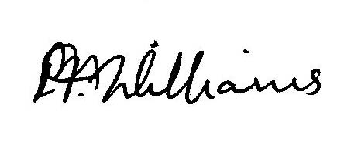
Pauline Williams
Housing Rights Coordinator
AMIDA

