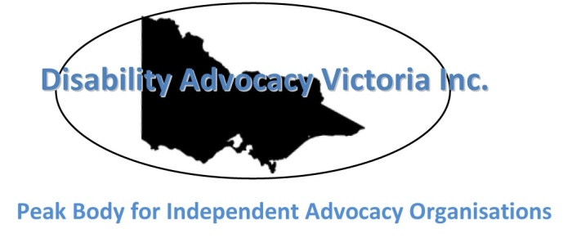

Disability Advocacy Victoria Inc.

e-news – November 2014
Welcome to Disability Advocacy Victoria’s November e-news. In our bi-monthly newsletters, we will be sharing stories that are relevant to DAV members and information that can be passed on to the wider community. If you have any feedback, or would like to include a feature in upcoming editions, please contact Caroline Livanos: caroline@thewritetouch.com.au

Latest news

Save the date – DAV Inc. Annual General Meeting 2014
We hope to see you at our 2014 Annual General Meeting, which will be held at Ross House (the Hayden Raysmith room), 245 Flinders Lane, Melbourne on Thursday 20 November (11.00 am – 1.00 pm). Please R.S.V.P to Caroline Livanos by Friday 14 November with any support requests.

Getting vocal as we head towards the state election
Women with Disabilities Victoria has developed a 2014 Victoria Election Statement that demands change in three vital areas: violence against women with disabilities; access to health care and health promotion; and access to education, housing, employment and support services. The statement has been distributed to the three major political parties, organisation members and relevant stakeholders. It has also been promoted on their website and at relevant events.
Deaf Victoria and DAV are leading a campaign to ensure the Department of Education and Early Childhood Development introduces a policy that gives deaf students the right to a qualified Auslan/English interpreter in schools when requested. Victorian government schools have obligations under domestic and international discrimination legislation to ensure access to education and current policies are considered inadequate. A letter has been sent to the Australian Greens, the Shadow Minister for Education and the Minister for Education.
In the lead up to the state election, the Victorian Council of Social Service (VCOSS) is leading a group, including community organisations, parents, students, teachers and school principals, to ensure all parties commit to helping families Cover the Costs of education. According to VCOSS, “The Education Maintenance Allowance (EMA) helps low-income families meet school costs. From 2015, the EMA will no longer support individual students. This will affect more than 200,000 Victorian school students.” Emma King, VCOSS CEO, says “The government needs to listen to all stakeholders and refine their plans to deliver genuine support for all disadvantaged students, regardless of where they live.”
Disability Services Commissioner’s year in review 2014
The office of the Disability Services Commissioner (DSC) has released Our year in review 2014, which summarises the activities and achievements of the DSC and the Victorian disability sector in 2014.
Key findings include:
- The number of new enquiries and complaints made to the DSC increased from 908 to 931 (an increase of 3 per cent) between 2012–13 and 2013–14.
- Enquiries and complaints related to: supported accommodation (37 per cent), Individual Support Packages (18 per cent), day services (13 per cent) and respite and case management (8 per cent).
- The top issues raised in complaints to DSC were centred around: quality of service; poor communication; physical and psychological health and safety; fees or charges; and concerns about complaint handling.
You can find out more about the experiences of people with disability and others involved in complaints by reading the 2014 Disability Services Commissioner’s Annual Report. Alternatively, you can read an interesting Challenge Paper written by Max Jackson and Margaret Ryan.

Victorian State Disability Plan 2013–16 Questionnaire
The Office for Disability has developed a questionnaire that asks about the experiences of adults with a disability in some of the important life areas covered by the state disability plan since it was launched in 2013. The questionnaire is sent out every six months. The results from this questionnaire will be compared to the results from April and May 2014 to monitor changes and understand key issues. Answers to the questionnaire will be used to help government improve its services and increase the participation of people with a disability in all areas of life.

National Disability Insurance Scheme (NDIS) – Rights Factsheets
Fitzroy Legal Service, Hobart Community Legal Service and Redfern Legal Centre have developed a series of NDIS Rights Fact Sheets to help people with rights-based legal information in relation to accessing the NDIS.
The Fact Sheets provide general information about what rights a person has under the NDIS and what they can do if they feel their rights are not being recognised.

Progress for people with disability in Victoria
The Minister for Disability Services and Reform, Mary Wooldridge, recently launched a report highlighting the positive impact the Victorian State Disability Plan 2013–16 is having on the lives of people with disability, their families and carers.
At home, play, school and work: Statement of Achievements outlines widespread improvements in the disability sector and shares practical examples of how the plan benefits individuals. According to Ms Wooldridge, “Key achievements have been made in education, housing, employment and transport – areas which people with disability have told us are essential to their social inclusion.” Find out more about the Statement of Achievements. Many DAV members would argue that the plan’s impact has not been so positive and that there is no evidence to support some of the claims made in this report.

Discrimination action against Coles Online
The need for accessible websites is in the spotlight thanks to with a Sydney woman who is launching a claim of unlawful discrimination against the Coles supermarket online shopping website. Gisele Mesnage, who is blind, wants Coles supermarket to make its website accessible for people who are blind or vision impaired. Read more about this story.

Did you know?
Google has introduced a program for non-profit organisations that will give you access to premium Google products and support. Once your application is approved, you can make the most of: free AdWords advertising to promote your website; superior capabilities on YouTube; free Google Apps such as gmail; and free licensing for Google Earth Pro. There are also some easy product tutorials available to get you started. To find out more, visit Google for Non-Profits.

