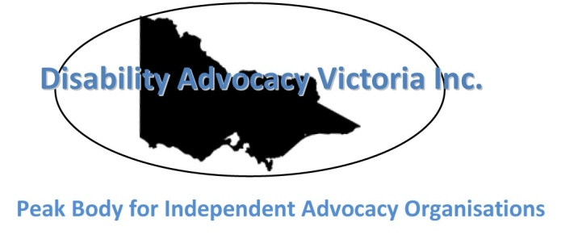

Disability Advocacy Victoria Inc.

E-news – December 2014
Welcome to Disability Advocacy Victoria’s end of year e-news. Everyone is busy this time of year, so we are keeping this issue short. Our next e-news will be February 2015. Again, if you have any feedback, or would like to include a feature, please contact Caroline Livanos: caroline@thewritetouch.com.au
Wishing you a safe and relaxing Christmas break!

Latest news

DAV Inc. Annual General Meeting 2014
We gathered for our Annual General Meeting on 20 November 2014 and had some interesting discussions. The 2014 AGM minutes and Annual Report can be found on our website.

Media releases
The new Victorian Labor Government has announced that it will establish a long overdue inquiry into disability care abuse with a broad focus across residential care facilities, day services and disability employment enterprises. Watch this space.
In the lead up to the state election, we distributed a media release about a proposed parliamentary inquiry into the abuse of people with disability in Victoria. We highlighted that the inquiry needs to cover all disability services, including the Department of Human Services and the Department of Education with a review of the Disability Services Commissioner’s powers.

Working with Victoria’s new Labor Government
Now that we have a new Victorian Cabinet, let’s build relationships and keep up the pressure to achieve best outcomes for people with disability.
Martin Foley MLA will be our new Minister. He has the portfolio of ageing, disability, housing and mental health. You can find out more about Martin, including his contact details here.

Social justice policy summary
The Victorian Council of Social Service (VCOSS) has summarised some of the important social justice policies announced by the ALP in the lead up to the 2014 State Election. VCOSS looks forward to working with the incoming Andrews Labor Government to ensure these commitments are met. Find out more.
Correspondence
On 26 November 2014, we sent a letter to Ms Miranda Bruyniks from the Office of the Disability Commissioner. Our letter outlined the barriers experienced by people with disability and their advocates when they made a complaint to the office. We look forward to receiving their response.
Website survey
We will be reviewing the DAV website over the Christmas break and sending out a 10 question survey to members so that the new look website meets your needs. Stay tuned for more details.

