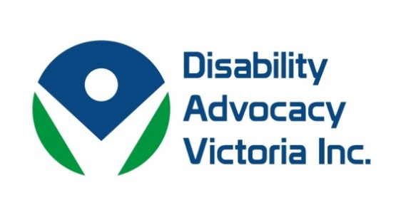

Dear Members,
Victoria’s Family and Community Development Committee is holding an inquiry into services for people with Autism Spectrum Disorder. Submissions close on 18 March 2016. We are aware that many of you would be providing services to people with Autism. DAV will be making a submission. If you have a contribution, even if it is in the form of a few dot points, we would be keen to receive it by 28 February. The Terms of Reference are below. Please email to manager@ddls.org.au
Terms of Reference
To the Family and Community Development Committee to inquire into, consider and report, no later than 31 May 2016, on services for people with autism spectrum disorder in Victoria, including but not limited to —
the prevalence of autism spectrum disorder in Victoria; the availability and adequacy of services provided by the Commonwealth, State and local governments across health, education, disability, housing, sport and employment services; the adequacy of services to be provided under the National Disability Insurance Scheme (NDIS); evidence of the social and economic cost of failing to provide adequate services; and the projected demand for services in Victoria.
Earlier this month Disability Advocacy Victoria commenced research in collaboration with Federation University.
The three topic areas of research include:
- Experiences of people who use alternative forms of communication in court, with Dr Marg Camilleri, who further investigates the question; the needs of people with complex communication needs in their interaction with the criminal and civil justice system.
- Issues experienced by parents with disabilities in the child protection system with Dr Angela Murphy - The lack of timely, coordinated response to the specific support needs of parents with a disability.
- Experiences of young people with disabilities who are in the education system and their contact with the justice system, commencing February 25th with Dr Jenene Burke and Dr Marg Camilleri.
Disability Advocacy Victoria would like to take this opportunity to acknowledge the commitment of DARU's coordinator, Robyn Gaile, who's valued contribution to this sector will sustain, and we would like to congratulate Robyn for her new endeavour at the Australian Federation of Disability Organisations (AFDO), who will be project managing the delivery of the Innovative Services Project, funded by the State Trustees Australia Foundation and National Disability Insurance Agency, which will investigate and promote high quality consumer led service models. We wish Robyn all the best!
We would also like to wish Sharon Granek, Program Manager for Women with Disabilities Victoria, all the very best for her new endeavours!
We would like to thank the members for their commitment and support to the values and work of Disability Advocacy Victoria. We understand that although we may not be able to influence the wider disability advocacy sector outside of our membership, for those who are keen to work together collaboratively we will pool our expertise and skills to bring much needed development of advocacy within Victoria.

