Disability Advocacy Victoria Inc.
Annual Report: 2018 -2019
The last twelve months have been a challenge for all of those working in the disability sector - organisations, and individuals who are both NDIS recipients or struggling to get onto the scheme, have faced unreasonable amounts of pressure. ‘The Australian’ recently reported that the scheme has spent more than half a billion dollars in one financial year on consultants and outsourced staff. Further, it is reported that some of the consultants have not gone through the required tendering process. From an accountability perspective this is a major concern for the Australian community, and in particular the advocacy sector who are struggling on behalf of the people they represent to gain the services/supports they are entitled to.
Disability Advocacy Inc. (DAV) is not directly funded by the government but receives a minimal income from Victorian Council of Social Services for its work on their committees and to assist with our administration. We are grateful for their contribution. We have been careful as to how we target our limited and voluntary resources to ensure we are accountable to our membership.
Our long-time administration support Kerry O’Hagan resigned at the beginning of the year to take on a new job which was a devastating blow to the organisation, tempered by the fact that she now works for one of our valued member organisations. Fortunately, we were able to replace her immediately with our new administration support person, Clare Dommissee. Both Kerry and Clare have provided a high quality level of support to the Board. The role is complex because of the limited resources the organisation has, but both Kerry and Clare have kept the wheels turning within the organisation with a strong commitment, and for this we are very grateful.
DAV became quickly aware of the increasing pressure on advocacy groups from feedback from the membership on their ever-increasing waiting lists, huge pressure on advocates, and the increased numbers of people contacting DAV directly for advocacy. This prompted the Board to complete a research survey to ascertain what the experiences were of organisations, and which areas of work were causing the most distress for their clients. It was no surprise that the NDIS was rated the highest area of demand, followed by education. We fed this back to both state and federal government Ministers, requesting their immediate attention and response.
Our Board members have represented the sector on a number of committees to push the key concerns for advocacy groups representing people with disabilities. These Committees included the Conference Committee of DARU/DAV/VCOSS ‘Strengthening Advocacy’ conference, VicDan – the joint advocacy legal advocacy group dealing with NDIS issues, input into the Best Practice in Disability Advocacy course, Disability Advocacy Resource Unit Governance Group, and representation on the Law Institute’s Victorian Disability Law Committee.
There have been a number of submissions we have jointly endorsed such as the Child Safety Standards, and a a number of others that you can find on our website.
Alongside this work, the Board has focused on quality issues for the organisation by reviewing all quality documents, including Board position descriptions, and revisiting the membership requirements for the organisation. There have been a number of groups and individuals wanting to join DAV over the year and we needed to be clear on the selection criteria of being ‘independent advocacy organisations’. DAV has been mindful not to venture into the membership space of its member organisations and establish any competing environment.
Further DAV has increased the number of its online meetings to ensure rural and regional members can access meetings and have input into the organisation. Over the year we also ran 4 open forums for members on a range of topics that were selected based on their relevance to the sector.
I would like to thank the voluntary Board members for their time and commitment to DAV and the disability sector, and particularly recognise their organisations for supporting the systemic work we do on their behalf.
I invite everyone to read our Strategic Plan for 2019 – 2023 to ascertain how we want to work with our membership and the wider community.

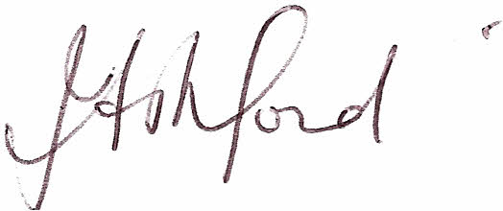
Jan Ashford
Chairperson

